1. Introduction
Continuous Integration and Continuous Delivery (CI/CD) is a development practice that automates the process of integrating, building, testing and deploying software. In this experiment, GitHub is used for source-code management and Jenkins is used to automate the CI/CD pipeline.

2. Pipeline Architecture
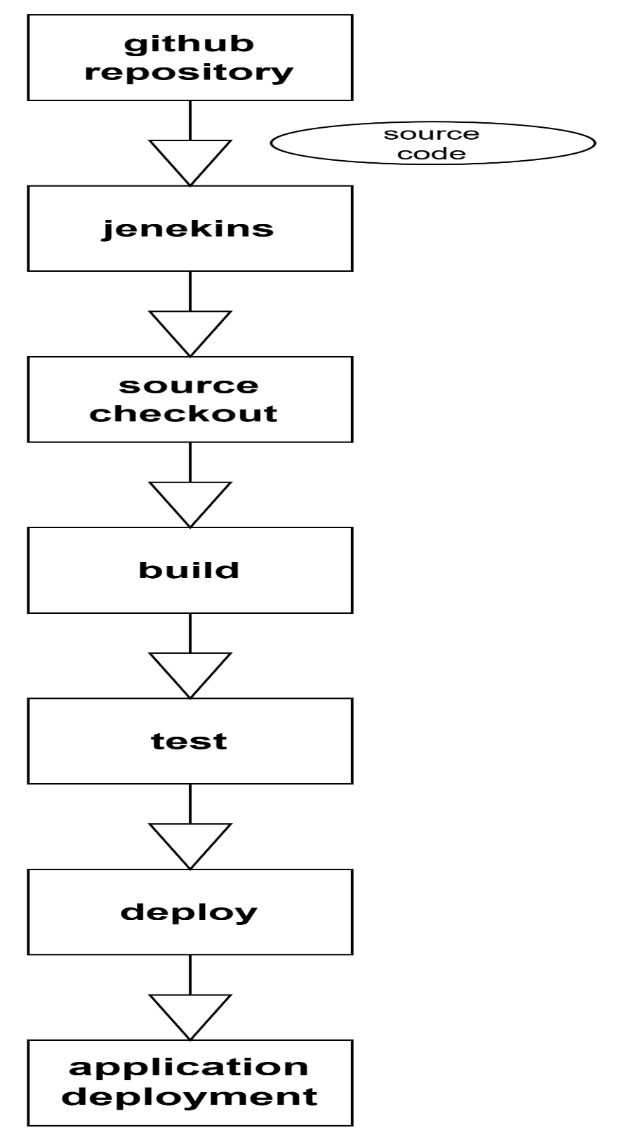

The workflow begins with the source code stored in GitHub. Jenkins retrieves the source code from the main branch and reads the Jenkinsfile. The Jenkinsfile defines three stages: Build, Test and Deploy. These stages are executed sequentially by Jenkins.
